October 7, 2020
On behalf of the Stonehaven Residents Committee, we are submitting these comments on the Environmental Impact study submitted on behalf of the Marianneville Stonehaven proposal to develop the lands known as 600 Stonehaven.
In early September we submitted our early comments on the application to the town and developer and commented to the developer that we were disappointed with the EIS study submitted with the application.
Since that time we have researched the EIS study and feel the study is incomplete and missing key elements that must be addressed. We believe a further comprehensive review by a knowledgeable qualified individual /company is essential and may result in discovery of further problems.
As a result, this note is being sent to the Town of Newmarket Planning department, the Regional Municipality of York, the Lake Simcoe Region Conservation Authority, the Ontario Ministry of Environment, Conservation, and Parks (MOECP) and for the information of the local indigenous community.
What Are the Issues That Need Addressing?
- Out of date field studies are problematic. Several of the cited studies are as old as 2015 (bird and amphibian). To be ecologically valid for decision-making studies must be carried out within 2 or, at the most, 3 years of the decision-making process.
- Out of date regulatory literature is problematic. In particular, the 2014 version of the planning act statement cited is no longer applicable. The current document (available February 2020, effective as of May 01, 2020) is Ontario Ministry of Municipal Affairs. 2020. Provincial Policy Statement, 2020 under the Planning Act. Queen’s Printer for Ontario, Toronto, 53 p. Although the report is dated February, 2020, it would have been prudent to anticipate the change in this key regulatory document at a date so close to the change and prepare the report accordingly.
- A significant aspect of the 2020 version of the Provincial Policy Statement is a requirement for Aboriginal Consultation. Specifically:
  - “4.3 This Provincial Policy Statement shall be implemented in a manner that is consistent with the recognition and affirmation of existing Aboriginal and treaty rights in section 35 of the Constitution Act, 1982.”
There is no indication that this issue has been addressed or that any local or regional Aboriginal communities have been officially notified of this proposed development.
- No information on turtle presence and habitat is presented in the EIS. However, it is known that turtles are present in the general area and, as the area includes suitable turtle habitat, it is more than likely they reside on the property. As all turtles are currently protected by provincial regulations a thorough turtle survey is required for the site and, if present as expected, appropriate protective designs and actions will be required.
The Town of Newmarket has already posted this sign in the area on Weslie Creek where the bridge crosses from Best Circle to Comfort Lane as evidence of turtle presence. The photos of the turtle by the fence (by Weslie Creek) are definitely of a Snapping turtle (Chelydra serpentina), a Species at Risk that was not noted on the consultant ecological survey. .
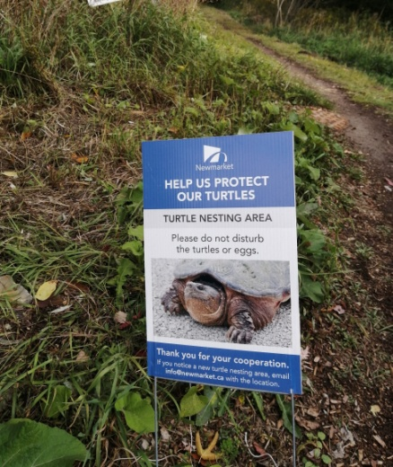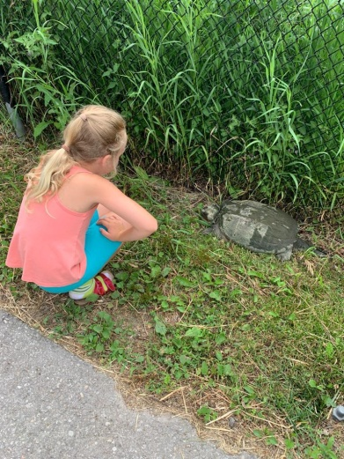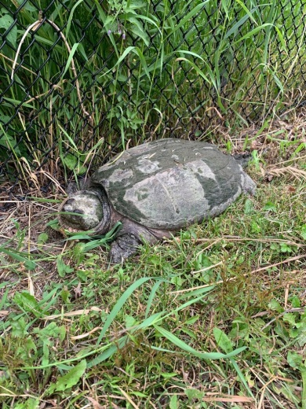

- Aquatic Species at Risk Oversight:
The redside dace is a minnow species at risk that is not mentioned in the EIS. On page 13 the EIS notes “A review of the MNRF Natural Heritage Information Centre (NHIC) and the DFO Species at Risk Critical Habitat mapping has indicated that there are no records of fish or mussel species at risk on or within the vicinity of the subject property.”However, it is well-known that the redside dace is present in the Holland River sub watershed. It has been reported as present in the Weslie Creek watershed (see LSRCA, 2000). As Weslie Creek is the watercourse that runs through the property, and is classified as a cool-water habitat in the EIS, it is suitable habitat for redside dace. As species-at-risk mapping identifies the presence of redside dace in upstream areas of Weslie Creek, and suitable habitat is also present downstream of the proposed development site, if this is not actual habitat, it is certainly is an essential contributing section of watercourse and particular efforts must be made both during construction and post-construction to prevent any increases in turbidity or increases in water temperature that would reduce the viability of this stream, both in the property or downstream, to support the endangered redside dace.
- No information on snake presence and habitat is presented in the EIS. Snakes are known to be present in the general area and, as the area includes suitable snake habitat, it is more than likely they reside on the property. A thorough on-site snake survey is required for the site. In particular, it is critical to establish if rocky areas used as winter hibernacula sites are present on the site as a substantial protective zone is required. Residents adjacent to this area have reported snakes present.
- The bird survey presented is focuses only on breeding birds and likely underestimates the species that use the site for a substantial portion of their lifecycle. An examination of the ebird.org site would provide a good general baseline for species reported in the area. For example, the nearby Newmarket--Mulock and Bayview wetland/SWM indicates that 132 bird species have been reported in that area, 87 for the current year. No raptors are identified in the breeding bird list, the only list provided. Raptor species that have been observed locally, such as the red-tail hawk and turkey vulture may find prey in this area, as would herons that are commonly seen in the area. Although they may not nest in this area, raptor nests have been observed in mature trees in the general area.
As the endangered Barn Swallow is known to occur in the area, and the local habitat is suitable, a more thorough examination of the local area other than just the existing building would be appropriate before dismissing the area as unimportant for this species.
A great Blue Heron is seen by local residents on the property as well. We are working to identify other bird species that may be locally rare.
- The study must also show the impact of removing virtually all trees from the application boundaries on the wildlife and fish species as shown above.
- The plant list appears to be somewhat limited, as some species that might be expected are not reported. For example, although Green Ash is reported as present, neither black nor white is; however, the area appears suitable for all three ash species.
- The EIS does not present a habitat review of extensive areas of long grass adjacent to water course. This is ideal habitat for a variety of nesting birds, as well as other organisms, and thorough examination of this habitat would provide a significantly improved perspective of the plant and animal life on the site.
- The limited evaluation of potential bat habitat on the site is inadequate to justify the minimal Bat Mitigation measures noted in Section 7.2.7 (p. 30). Bats are present in the area and, as residents, must roost somewhere. Given the Endangered status of all four species of bat that are known to be present in the general area, a more thorough field study is necessary before making recommendations for appropriate mitigation measures. It would be worthwhile for further monitoring that extends beyond the identification of roosting habitat,
- Since the underground storage/release of stormwater into the watershed is a newer technique, the impact of 200+ dwellings, 100 year storms and the loss of virtually all trees needs to be factored in
- Some of the reported species by adjacent neighbours include deer, fox, coyotes, raccoons, opossum, and mink. This was just a quick list by asking committee members.

This is a short review to point out areas we have seen that need to be addressed and we believe are required by the current requirements of LSRCA, the Region of York and the Town of Newmarket. Any EIS used by the town of Newmarket must in planning decision-making thoroughly and adequately address all aspects of the currently applicable regulatory environmental guidance.

